|  |  |
| --- | --- |
| A picture containing logo  Description automatically generated A logo with text on it |  |

**Global Tool Operation Specification  
for ams OSRAM**

G-TOS

|  |  |
| --- | --- |
| Equipment manufacturer: | <Please fill out> |
| Equipment type/model: | <Please fill out> |
|  |  |
| Last edited date: | <Please fill out> |
| Edited by: | <Please fill out> |

Document Version 2.10

G-TOS for ams OSRAM

|  |  |
| --- | --- |
| **Trusted Reviewers** | |
| **Name** | **Department** |
| Mohd Fitri Abd Manaf | IT OT FE KLM2 |
| Roselle Anicia Dagasdas | IT OT FE KLM2 |
| Sarah Chiew Yen Toh | IT OT FE KLM1 |
| Ralf Suess | IT OT FE RBG |
| Hubert Raab | IT OT FE RBG |
| Diana Gnanathikam | IT OT BE PEN |
| Jian Ting Ding | IT OT BE WUX |
| Chong, Chia Jiun | IT OT FEK KLM SV |
| Rutheran Karinalili | IT OT FE AMHS |

|  |  |  |  |
| --- | --- | --- | --- |
| **Approved By:** | | | |
| **Name** | **Department** | **Email Address** | **Date** |
| Azlan Snawi | IT OT FE KLM1 | [Azlan.Snawi@ams-osram.com](mailto:Azlan.Snawi@ams-osram.com) |  |
| Kale Dasan Shamugam | IT OT FE KLM2 | [kaledasan-shanmugam@ams-osram.com](mailto:kaledasan-shanmugam@ams-osram.com) |  |
| Raab, Hubert | IT OT FE RBG | [hubert.raab](mailto:christine.zenz@osram-os.com)@ams-osram.com |  |
| Cheng Alex | IT OT BE EI PG | [alex.cheng@ams-osram.com](mailto:alex.cheng@ams-osram.com) |  |
| Wang, Gang - William | IT OT BE WUX | Gang.Wang@ams-osram.com |  |

|  |  |  |  |  |  |
| --- | --- | --- | --- | --- | --- |
| **To Be Informed:** | | | | | |
| **Name** | **Department** | | **Email Address** | | **Date** |
| Yvonne Goh | P CX | | yvonne.goh@ams-osram.com | |  |
| Timm Bauer | | P CX FE-EPI | | timm.bauer@ams-osram.com |  |
| Yee Lin See Tau | P CX | | yee-lin.see-tau@ams-osram.com | |  |
| KLM1 EI Engineers | IT OT (FEK1) | | FEKITPSEIM@osram-os.com | |  |
| KLM2 EI Engineers | | IT OT (FEK2) | | [DL-OOS_KLM_FEK2_OT_EI@ams-osram.com](mailto:DL-OOS_KLM_FEK2_OT_EI@ams-osram.com) |  |
| RBG EI Engineers | IT OT (RBG) | | [ORG-OS-RBG-IT-OT-EIG@osram.com](mailto:ORG-OS-RBG-IT-OT-EIG@osram.com) | |  |
| BEP EI Engineers | IT OT (BEP) | | [DL-IT-PEN-OT-EI@osram.com](mailto:DL-IT-PEN-OT-EI@osram.com) | |  |
| Samivel Krishnamoorthy | | IT OT FE KLM2 | | samivel.krishnamoorthy@ams-osram.com |  |
| Gwen Liu | | IT OT BE EIG | | gwen.liu@ams-osram.com |  |

Document Revision

|  |  |  |  |
| --- | --- | --- | --- |
| **Rev.** | **Date** | **Author** | **Description** |
| 2.0 | 31 Jul 2017 | Global TOS Team | * Added E84 support for RBG. * Removed E42 (inactive at SEMI). * Improved some descriptions and corrected typos. |
| 2.1 | 20 Nov 2017 | Global TOS Team | * Corrected chapter numbering from 4.4 onwards * Removed duplicated items for Cassette process status events * Added note at E84 definitions. * Removed SEMI E10 in chapter 4.1 * Format requirements of CEID, ALID, SVID * Definition update of the event ProcessingSubstrateFinished * Added notes at Equipment Capability Buy-Off Requirement. * Added notes at 7.4 for Monitored Key Process Variables (KPV) * Added a requirement for the equipment 3D image * Removed statement regarding final payment acceptance in chapter 1.1 |
| 2.2 | 17 Aug 2018 | Global TOS Team | Part I Updates:   * 4.8.2 Data Quality: Added new requirements (4.8.2.6 /.7 and /.8) * 6.1.3 Substrate Detection Requirement Specification requirement 6.1.3.5 * 7.2.2 Loading / Unloading Module or Chamber: Added new requirement (7.2.2.2) * 8.6 Process Step Events: Added new requirement (8.6.1.3) * 8.7 Events for Preparation or Reconditioning in a Module or Chamber: New Chapter   Part II Updates:   * 2.2 Control State Model: Modified 2.2.5 Description * 2.10 Process Recipe Management: Corrected spelling in 2.10.1 and 2.10.6 * 2.12 Equipment Terminal Services: Corrected spelling in 2.12.1 |
| 2.3 | 14 Oct 2019 | Global TOS Team | Part I Updates:   * 2.2 Roles and Responsibly. Added new requirement; updated KPV for ams OSRAM Vendor / Process / Equipment / BT Engineer to fill up.   Part II Updates:   * 2.4 Event Report. Added new checklist (2.4.13) Collection Event Namelist Request * 6 Characterization Result: Sign off page to include ams OSRAM Process/Equipment/BT Engineer & CIM Manager |
| 2.4 | 24 Aug 2020 | Global TOS Team | Part I Updates:   * New requirement: 4.18 SECS Remote Command to Switch On and Off from a Module or Chamber   Part II Updates:   * 2.4 Event Reporting. Added remarks regarding event reporting on 2.4.2 and 2.4.3 * 2.8.2 Additional. Removed test name PP-UPDATE * 2.8.2 Additional. 2.8.2.1 Modified description for PP-SELECT test name * 3.3 Substrate Validation Requirement for ams OSRAM BE. 3.3.1 Removed PP-Update for DATASET. Added in DEVICE-INFO-UPDATE test name * 3.3 Substrate Validation Requirement for ams OSRAM BE Modified header ** Refer Appendix 7.1 for System Flow Diagram and Device/Wafer Validation * 3.4 Substrate Mapping. 3.4.5 Added Update Device Info test name * 7.1 Device and Wafer Validation. Modified to include device/wafer validation * 7.2 Set Device Info. Modified for sending device info from host to equipment * 7.3 Set Wafer Info. Modified for sending wafer info from host to equipment * 7.4 Update Device Info. Added requirements for updating device info from equipment to host * 7.5 Equipment System Scenario. Removed PP-Update. Added in Set Device/Wafer Info and Update device info |
| 2.5 | 05 Oct 2020 | Global TOS Team | * Added requirements for SMIF equipment in RBG * Added 4.8 4.8 SECS/GEM Host communication and SMIF ports * Added 4.10.1.6 SMIF options for error handling * Added 4.20 REMOTE commands for equipment configured for SMIF * 6.1.4 Added SMIF pod where cassette is mentioned * 6.1.7 Added note that RFID location at SMIF pod still needs to be defined * Added 8.2 SMIF Pod Loading/Unloading * Added 9.3 9.3 SMIF specific variables * Removed PART II Section 7.6 * Corrected grammatical, formatting mistakes and removed duplicating/redundant entries |
| 2.6 | 12 Nov 2020 | Global TOS Team | * 10.2 Added item for definition of location of PI/O interface * 6.1.7 Added figure for RFID positions in SMIF Pod and 200mm carrier * Updated RFID reader article numbers * Updated figure 6 picture |
| 2.7 | 08 Mar 2021 | Global TOS Team | Part I Update:   * 7.2.3 Added “Device” in section title * Removed 7.2.3.1 as it has the same definition with 7.2.3.2 * 7.2.3.1 Modified to include in “Device” * Added 7.2.3.3 for Device / Substrate validation   Part II Update:   * 3.3.1 Renamed test name to Set Device / Substrate Info * 3.4.5 Modified to include in “Substrate” * Added 3.4.6 Device / Substrate Validation EC Request * Added 3.4.7 Device / Substrate Validation EC Set * 7.1 Device and Substrate Validation. Renamed “wafer” to “substrate” |
| 2.8 | 14 Sep 2021 | Global TOS Team | * Updated Trusted Reviewers form Christian Schmid to Ralf Suess form DMA RBG * Updated ‘Trusted Reviewers’: Gao, Xing – Mark and ‘Approved by‘: Wang, Gang – William from DMA WUX. * Update OSRAM to ams OSRAM. |
| 2.9 | 01 Dec 2021 | Mohd Fitri Abd Manaf  Kale Dasan (Dass), Shamugam, Samivel Krishnamoorthy | * Changed references to ams OSRAM department name “DMA / IT” to “OT SEMI” * Replaced ALL Area field stated as RBG to ALL in section 3.3 & 9.3. * 4.1.1.7 & 7.2.3.2 SEMI E142 Capability Area changed from BE to ALL * 4.14 Consolidated ‘*IT-PROD Specification Rev 1.3’* in this section and removed redundancy. * 4.14.1.19 Added new requirement for second network card for accessibility purposes * Removed 4.15 ‘Anti-Virus’ and merged with 4.14 as ‘4.14 Operating System, Third-Party Software, and IT Security’ * Changed E84 and SMIF related requirement applicable Area from RBG only to FE to be more general * Corrected the statements and removed duplications in sections 6.1.4, 6.1.5 & 6.1.6 * 8.2.1.6 Added Lot ID variable for equipment with batch processing that require AMHS to manage the output load ports * 3.4.1 & 3.5.1 (Part ll) Changed reference of SEMI E142 document name to *‘Global_SEMI_E142_Substrate_Mapping_Specification‘* * 3.2 & 3.4 (Part ll) Removed 'ONLY Applicable for ams OSRAM Back Ends' and make the requirement generic for both Front End and Back End * Figure 12 Replaced AGV/RGV only image, to include image with OHT - reflecting KLM site requirement |
| 2.10 | 23 Aug 2024 | Kale Dasan (Dass),  Ralf Suess | * Updated reviewers, approver and informed contacts * Added SEMI E87, E90 in 4.1.1.8, 4.1.1.9 and in References table. * Change Category in 4.7.1.1 – 4.7.1.4 to be ‘Mandatory’ * Updated 4.9.2.7, 9.1.1.2 for all SVID or DVID of sensor data quarriable by Host * Updated requirement in 6.1.4.6 to have proper cable management for operator ID reader (Rbg) * Updated requirement in 6.1.5.4 for RFID hardware will be provided by ams OSRAM to Supplier * Added back view image for Hermos RFID reader in Figure 6. * Updated 6.1.6.9 for Supplier to test RFID readability * Added 6.1.7.7, 6.1.7.9, 6.1.7.10, Substrate ID reading with SEMI E90 and E39 compliance. * Updated 8.7.1.1, 8.7.1.2 and Added Figure 11 for recipe step looping’s events and VIDs from equipment * Appendix related to substrate mapping moved to SEMI E142 specification. * Removed Part II as not relevant to supplier. Each site responsibility to manage equipment characterization testing. |

References

|  |  |
| --- | --- |
| **No** | **Title** |
| 1. | SEMI E142: Specification for Substrate Mapping |
| 2. | SEMI E5: SEMI Equipment Communication Standard 2 Message Content (SECS-II) |
| 3. | SEMI E30: Generic Model for Communications & Control of MFG Equipment (GEM) |
| 4. | SEMI E37: High Speed SECS Message Services (HSMS) Generic Services (GS) |
| 5. | SEMI T9: Specification for Marking of Metal Lead-Frame Strips with A Two-Dimensional Data Matrix Code Symbol |
| 6. | SEMI E84 Specification for Enhanced Carrier Handoff Parallel I/O Interface |
| 7. | SEMI E87 Specification for Carrier Management (CMS) |
| 8. | SEMI E90 Specification for Substrate Tracking |
| 9. | Procurement Spec in Penang, TOS in RBG |

Contents

I. List of Figures 9

II. List of Tables 9

1 Summary 10

1.1 Introduction of Equipment Capability Buy-Off Requirement 10

1.2 Confidentiality 10

1.3 Limitation 10

1.4 Scope 10

1.5 Definition of Areas 11

1.6 Definition of Requirement Categories 11

2 Basic Requirements for the Supplier 12

2.1 Global TOS Response of the Supplier 12

2.2 Roles and Responsibilities 13

2.3 Correspondence 14

2.4 Contact Details 14

2.5 General Information 14

3 Equipment Acceptance Steps 15

3.1 Support of the Equipment Vendor 15

3.2 Equipment Acceptance Criteria 16

3.3 Order Acceptance 17

3.4 Delivery Acceptance 18

3.5 Preliminary Acceptance 18

3.6 Final Acceptance 19

4 Software Requirements 20

4.1 Supported SEMI Standards and Guidelines 20

4.2 Compliance with SEMI E30 21

4.3 GEM Compliance (Fundamental GEM Requirements) 22

4.4 GEM Compliance (Additional Capabilities) 23

4.5 Format of Event ID, Alarm ID, Variable ID and Constant ID 24

4.6 SEMI E37 HSMS 25

4.7 Compliance with SEMI E116 Equipment Performance Tracking 26

4.8 SECS/GEM Host Communication and SMIF Ports 26

4.9 Requirements for Advanced Process Control 27

4.9.1 Equipment Data Interface 27

4.9.2 Data Quality 27

4.10 General Requirements User Interface 28

4.11 Configuration of the SECS Interface 29

4.12 Equipment Behavior with Usage of the SECS interface 29

4.13 Slot Integrity 29

4.14 Operating System, Third-Party Software, and IT Security 30

4.15 Equipment Log Files 32

4.16 Recipe Management 33

4.16.1 General Process Recipe 33

4.16.2 Formatted Recipes 34

4.16.3 Unformatted Recipe 34

4.17 SECS Remote Command for Single Wafer Processing 34

4.18 Switching ON and OFF a Module or Chamber 35

4.19 REMOTE Commands for Equipment Configured for SMIF 35

5 Basic Hardware Requirements 36

5.1 Supported SEMI Standards and Guidelines 36

6 Specific Hardware Requirements 37

6.1 Equipment Hardware 37

6.1.1 3D Image of the Equipment 37

6.1.2 Cassette Detection 37

6.1.3 Substrate Detection Requirement 38

6.1.4 Installation of RFID Antenna for Operator ID Reading 39

6.1.5 Installation of RFID Reader for Operator ID, Cassette ID & SMIF ID Reading 42

6.1.6 Integration of the Carrier & SMIF Pod RFID Antenna 43

6.1.7 Substrate ID Identification 46

6.1.8 Electronic Communication I/O Ports 47

7 Equipment Operational Checklist 48

7.1 Substrate and Carrier Specification 48

7.2 Material Movement / Processing 48

7.2.1 Loading / Unloading Port Identification 48

7.2.2 Loading, Processing and Unloading in a Module or Chamber 49

7.2.3 Material / Substrate / Device Identification 50

8 Equipment Events Implementation 51

8.1 Cassette (Magazine) Detection and Cassette Slot Mapping 51

8.2 SMIF Pod Loading/Unloading 52

8.3 Cassette (Magazine) Process Events 53

8.4 Substrate Detection, Substrate ID Reading Events 54

8.5 Process Events 55

8.6 Substrate Process Events in Module or Chamber 56

8.7 Process Step Events in a Module or Chamber 57

8.8 Events for Preparation or Reconditioning in a Module or Chamber 59

9 Status Variables Implementation 60

9.1 Common 60

9.2 Equipment with Load Port 60

9.3 SMIF Specific Variables 61

10 Enhanced Carrier Handoff Parallel I/O Interface (SEMI E84) 62

10.1 Standard Compliance 62

10.2 Photo Coupled PI/O Interface 63

10.3 Operation 65

# List of Figures

Figure 1: Example of a Requirement 12

Figure 2: Equipment Acceptance Procedure 15

Figure 3: Example of a 3D Image of the Equipment 37

Figure 4: Communication of the Host, Cassette ID and Operator ID Reader 39

Figure 5: Operator ID Antenna 41

Figure 6: Hermos RFID Reader 42

Figure 7: Hermos RFID Antennas - Rod and Block Type 44

Figure 8: RFID Transponder locations - PFA 8 inch and Film Frame 8 inch Carrier 44

Figure 9: RFID Transponder in SMIF Carrier & SMIF Pod (OS: Transponder on the Right Side) 45

Figure 10: Events for Loading, Processing & Unloading of the Substrate with Actual Logistic Data 49

Figure 11: Example for Recipe Step Looping 57

Figure 12: Examples for Recipe START/END Events 58

Figure 13: SEMI E84 Connector A Location 64

# List of Tables

Table 1: Definition of Areas 11

Table 2: Definition of Requirement Categories 11

Table 3: Global TOS Response 12

Table 4: Contact Details 14

Table 5: General Information 14

Table 6: Error Classification 16

# Summary

## Introduction of Equipment Capability Buy-Off Requirement

The Global Tool Operation Specification for OSRAM Opto Semiconductors (G-TOS for ams OSRAM) lists and describes the respective equipment automation requirements for semiconductor Epitaxy, Front End and Back End Equipment Integration. ams OSRAM will use this document to all purchased or leased equipment.

The Global TOS defines how ams OSRAM intends to use the equipment automation features and function the automation demands of all ams OSRAM sites for equipment hardware and software. All equipment to be procured by ams OSRAM are to be pre-validated against this document. This is so that, it can be verified that the equipment procured is able to fit into ams OSRAM’s CIM landscape prior to procurement.

ams OSRAM demands that the equipment vendor meets the requirements of the Global TOS for a successful collaboration and a [prosperous](http://de.pons.com/%C3%BCbersetzung/englisch-deutsch/prosperous) integration of the equipment.

The Global TOS establishes the requested support of documentation, communication and correspondence and SECS functionalities. At the same time the Global TOS is a checklist for the characterization (test of SECS interface) or buy-off of the SECS features.

Equipment vendors **shall not charge** ams OSRAM for bug fixes of equipment software during or after warranty period.

## Confidentiality

The Global TOS is confidential. The Global TOS is the intellectual property of ams OSRAM and may not be copied, modified or otherwise duplicated or changed without the written explicit permission of ams OSRAM.

## Limitation

The document does not define the equipment requirements for stability, reliability, or qualification.

## Scope

The document covered the semiconductor Epitaxy, Front End (Kulim, Regensburg, and Penang) and Back End (Penang and Wuxi).

All sites of ams OSRAM, e.g. Kulim, Penang, or Regensburg, shall use the Global TOS for the equipment procurement.

The result of which is that all the requirements of the Global TOS are checked, e.g. SECS tests / characterization, by the site who buys the equipment and the tests covers all requirements of all sites.

## Definition of Areas

|  |  |
| --- | --- |
| **Area** | **Definition** |
| ALL | Requirement is relevant for all sites of ams OSRAM |
| BE | Requirement is relevant for all sites of ams OSRAM with a Back End (BE) |
| FE | Requirement is relevant for all sites of ams OSRAM with a Front End (FE) |
| KLM | Requirement is only relevant for the site Kulim of ams OSRAM |
| PEN | Requirement is only relevant for the site Penang of ams OSRAM |
| RBG | Requirement is only relevant for the site Regensburg of ams OSRAM |
| WUX | Requirement is only relevant for the site Wuxi of ams OSRAM |

Table 1: Definition of Areas

## Definition of Requirement Categories

|  |  |
| --- | --- |
| **Category** | **Definition** |
| Mandatory | The requirement shall be fulfilled. |
| Optional | The requirement can be fulfilled and has to be decided from case to case. |

Table 2: Definition of Requirement Categories

# Basic Requirements for the Supplier

This chapter describes which information must be delivered by the supplier to ams OSRAM. The response of supplier will be used to inspect the availability of the required automation features for a successful delivery.

This document lists the requirements in a numeric format (4th level). The document provided by ams OSRAM has the demands and must be filed out by supplier and send back to ams OSRAM.

Example:

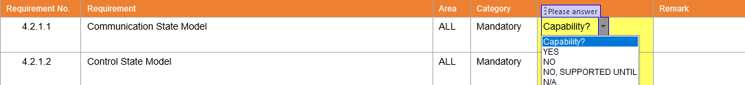

Figure 1: Example of a Requirement

## Global TOS Response of the Supplier

|  |  |  |  |  |  |
| --- | --- | --- | --- | --- | --- |
| Requirement No. | Requirement | Area | Category | Capability | Remark |
|  | The equipment vendor shall answer all requirements (completely) in the column “Capability”. | ALL | Mandatory | Capability? |  |

The following choice of answers (response) are accepted:

|  |  |
| --- | --- |
| Response | Description |
| YES | Means the equipment of the supplier supports and fulfils the specific requirement. |
| NO, SUPPORTED UNTIL | Means the equipment of the supplier does not support and fulfill the specific requirements today. The supplier will deliver this requirement at defined date. The realization costs must be part of the quotation. |
| NO | Means the equipment of the supplier does not support the specific requirement. The supplier does not have an alternative solution or does not have a proposal to meet the specific requirement. |
| N/A | Means that the specific requirement is not applicable to the equipment type. |

Table 3: Global TOS Response

|  |  |  |  |  |  |
| --- | --- | --- | --- | --- | --- |
| Requirement No. | Requirement | Area | Category | Capability | Remark |
|  | The supplier shall submit the filled-out document within 14 days after receiving and before a purchase order. | ALL | Mandatory | Capability? |  |
|  | The equipment vendor shall return the document to the OT SEMI department. | ALL | Mandatory | Capability? |  |
|  | The equipment vendor shall ensure equipment fulfills all relevant SEMI standards. | ALL | Mandatory | Capability? |  |

## Roles and Responsibilities

**Equipment Supplier:**

To fulfill and ensure equipment parameters required by ams OSRAM Process/Equipment/BT Engineers are available via SECS GEM. Once fulfilled, table below needs to be filled in **Parameter Type** and **DVID/SVID/ECID** columns.

**ams OSRAM Process/Equipment/BT Engineers:**

To identify which equipment parameters are required for process/equipment control purpose. Once identified, table below need to be filled in **Equipment Parameter Name** column.

For any dispute on KPV name in **Equipment Parameter Name** column**,** equipment supplier should communicate with Process/Equipment/R&D Engineers to determine & agree on standard KPV name to be used.  
 *\*\* Please refer to build sheet/ work instruction (APA) to fill in below table. (Process Engineers will have this details)*

|  |  |  |  |
| --- | --- | --- | --- |
| No. | Equipment Parameter Name | Parameter Type (DVID, SVID or ECID)? | DVID/SVID/ECID |
|  |  |  |  |
|  |  |  |  |
|  |  |  |  |
|  |  |  |  |
|  |  |  |  |
|  |  |  |  |
|  |  |  |  |
|  |  |  |  |
|  |  |  |  |
|  |  |  |  |
|  |  |  |  |
|  |  |  |  |
|  |  |  |  |
|  |  |  |  |
|  |  |  |  |
|  |  |  |  |
|  |  |  |  |
|  |  |  |  |
|  |  |  |  |
|  |  |  |  |
|  |  |  |  |

*\*\* Rows to be added when necessary or supplemented as Attachment*

## Correspondence

|  |  |  |  |  |  |
| --- | --- | --- | --- | --- | --- |
| Requirement No. | Requirement | Area | Category | Capability | Remark |
|  | Each correspondence regarding Global TOS between the supplier and ams OSRAM shall be in English. | ALL | Mandatory | Capability? |  |

## Contact Details

|  |  |  |  |  |  |  |  |
| --- | --- | --- | --- | --- | --- | --- | --- |
|  | Name | Title | Address | Office phone | Mobile Phone | Fax | E-Mail Address |
| Primary point of contact: | <Please fill out> |  |  |  |  |  |  |
| Local supplier representative: | <Please fill out> |  |  |  |  |  |  |
| Automation / software expert: | <Please fill out> |  |  |  |  |  |  |
| Sales representative: | <Please fill out> |  |  |  |  |  |  |

Table 4: Contact Details

## General Information

|  |  |
| --- | --- |
| Equipment manufacturer: | <Please fill out> |
| Equipment type/model: | <Please fill out> |
| Equipment processing unit: (Batch / Single-Substrate) | <Please fill out> |
| Equipment process type: (CVD/PVD, Etch, Lithography, Metrology, ...) | <Please fill out> |
| Cluster equipment  (specify chambers): | <Please fill out> |
| Operating system version, service pack: (e.g. Windows Server 2008 R2) | <Please fill out> |
| Third party software, version: (e.g. Microsoft SQL Server 2012) | <Please fill out> |
| SECS software revision, rev., date: | <Please fill out> |
| SECS documentation, title, rev., date: | <Please fill out> |
| SECS communication software driver (OEM supplier, rev.): | <Please fill out> |

Table 5: General Information

# Equipment Acceptance Steps

The acceptance of the equipment interface by ams OSRAM follows a process divided into several steps. The following sections describe this procedure in detail.



Figure 2: Equipment Acceptance Procedure

## Support of the Equipment Vendor

|  |  |  |  |  |  |
| --- | --- | --- | --- | --- | --- |
| Requirement No. | Requirement | Area | Category | Capability | Remark |
|  | The equipment vendor shall support ams OSRAM with senior (software) engineers in all phases. This support can be contacted by e-mail and telephone. | ALL | Mandatory | Capability? |  |
|  | The software engineer shall have a deep knowledge about SECS / GEM and shall be on site. | ALL | Mandatory | Capability? |  |
|  | In the event the solution delivered by vendor does not work within 15 days ams OSRAM expects the equipment vendor to be **on-site** and ensure full closure of **ALL** open items in 7 working days. | ALL | Mandatory | Capability? |  |

## Equipment Acceptance Criteria

The equipment acceptance steps validate the Global TOS requirements. The ‘Part II’ of the Global TOS specifies the general software tests by test cases. ams OSRAM will document all open items in a list of deviations. Each open issue has a priority and error classification:

|  |  |
| --- | --- |
| Error Classification | Description |
| Minor | This issue is a missing feature or an error, but the Equipment Integration is possible. |
| Major | The issue is critical, but a work-around is available. Nonetheless the error must be fixed by the equipment vendor. |
| Block | The issue prevents the Equipment Integration of the equipment. A work-around of the Equipment Integration or manufacturing execution system is not possible, or the effort is not acceptable for ams OSRAM. |

Table 6: Error Classification

|  |  |  |  |  |  |
| --- | --- | --- | --- | --- | --- |
| Requirement No. | Requirement | Area | Category | Capability | Remark |
|  | The equipment vendor shall provide a shipment date for the error correction for all issues with classification major and block. | ALL | Mandatory | Capability? |  |
|  | The equipment vendor shall formally inform ams OSRAM about the resolved issues. ams OSRAM closes the issues after a successful retest. | ALL | Mandatory | Capability? |  |

## Order Acceptance

|  |  |  |  |  |  |
| --- | --- | --- | --- | --- | --- |
| Requirement No. | Requirement | Area | Category | Capability | Remark |
|  | The equipment vendor supplies the filled out Global TOS document. | ALL | Mandatory | Capability? |  |
|  | The equipment vendor shall supply the SECS / GEM documentation or manual. | ALL | Mandatory | Capability? |  |
|  | The equipment vendor shall supply a SECS manual of the equipment based on the SEMI E30 requirements for documentation. | ALL | Mandatory | Capability? |  |
|  | The SECS manual must contain the GEM compliance statement (SEMI E30). | ALL | Mandatory | Capability? |  |
|  | The equipment vendor shall provide a list with all valid variables and constants of the equipment (SECS).  The list of events (CEID) should be delivered in csv format. The list must contain CEID, event name and description. | ALL | Mandatory | Capability? |  |
|  | The equipment vendor shall provide a list with all valid variables and constants of the equipment (SECS). The list of variables (DVID, SVID) and constants (ECID) should be delivered in csv format. The list must contain ID, variable name, format (data type), variable type, default value, minimum value, maximum value, unit and description. | ALL | Mandatory | Capability? |  |
|  | The equipment vendor shall provide a list with all valid alarms of the equipment. The list of alarms (ALID) should be delivered in csv format. The list must contain ALID (Alarm ID), alarm text and alarm category. | ALL | Mandatory | Capability? |  |

## Delivery Acceptance

|  |  |  |  |  |  |
| --- | --- | --- | --- | --- | --- |
| Requirement No. | Requirement | Area | Category | Capability | Remark |
|  | ams OSRAM carries out an acceptance test of the equipment **before delivery occurs**. This test checks the completeness of the required hardware, software, and documentation for Equipment Integration. | ALL | Mandatory | Capability? |  |

For proving the readiness of the equipment for Equipment Integration the vendor supplies self-tests.

|  |  |  |  |  |  |
| --- | --- | --- | --- | --- | --- |
| Requirement No. | Requirement | Area | Category | Capability | Remark |
|  | The equipment vendor shall perform a full self-test of the ‘Equipment Characterization SECS / GEM’ test plan 30 days before the delivery occurs. The results of the test must be made available for ams OSRAM. | ALL | Mandatory | Capability? |  |

## Preliminary Acceptance

|  |  |  |  |  |  |
| --- | --- | --- | --- | --- | --- |
| Requirement No. | Requirement | Area | Category | Capability | Remark |
|  | The equipment SECS / GEM characterization of ams OSRAM is successful. | ALL | Mandatory | Capability? |  |
|  | All open items have an agreed delivery date. | ALL | Mandatory | Capability? |  |
|  | The equipment vendor shall provide the pre-documentations of the equipment. | ALL | Mandatory | Capability? |  |

## Final Acceptance

|  |  |  |  |  |  |
| --- | --- | --- | --- | --- | --- |
| Requirement No. | Requirement | Area | Category | Capability | Remark |
|  | All supported (YES) and supported until (NO, SUPPORTED UNTIL) requirements of the document are delivered by the equipment vendor | ALL | Mandatory | Capability? |  |
|  | All BLOCK and MAJOR open issues are resolved and delivered. The retest of ams OSRAM was successful | ALL | Mandatory | Capability? |  |
|  | The equipment interface is stable for the period of four weeks in the productive environment | ALL | Mandatory | Capability? |  |

# Software Requirements

This chapter describes the software-related requirements of ams OSRAM. The response of supplier will be used to inspect the availability the required automation features for a successful delivery.

## Supported SEMI Standards and Guidelines

|  |  |  |  |  |  |  |  |
| --- | --- | --- | --- | --- | --- | --- | --- |
| Requirement no | Requirement | Area | | Category | | Capability | Remark |
|  | SEMI E5 SEMI Equipment Communications Standard 2 Message Content (SECS-II) | ALL | | Mandatory | | Capability? |  |
|  | SEMI E30  Generic Model for Communications and Control of SEMI Equipment (GEM) | ALL | | Mandatory | | Capability? |  |
|  | SEMI E37  High-Speed SECS Message Services (HSMS) | ALL | | Mandatory | | Capability? |  |
|  | SEMI E37.1  High-Speed SECS Message Services Single-Session Mode (HSMS-SS) | ALL | | Mandatory | | Capability? |  |
|  | SEMI E39  Object Services Standard: Concepts, Behavior and Services | ALL | | Mandatory | | Capability? |  |
|  | SEMI E116 Specification for Equipment Performance Tracking | | ALL | | Mandatory | Capability? |  |
|  | SEMI E142 Specification for Substrate Mapping where good/bad binning information are processed i.e Metrology, Visual Inspection, Probing, etc tools | | ALL | | Mandatory | Capability? |  |
|  | SEMI E87 Specification for Carrier Management (CMS) | | ALL | | Mandatory | Capability? |  |
|  | SEMI E90 Specification for Substrate Tracking | | ALL | | Mandatory | Capability? |  |

## Compliance with SEMI E30

The semiconductor manufacturing equipment shall comply with SEMI E30 (GEM). Essentially equipment capabilities and scenarios are:

|  |  |  |  |  |  |
| --- | --- | --- | --- | --- | --- |
| Requirement No. | Requirement | Area | Category | Capability | Remark |
|  | Communication State Model | ALL | Mandatory | Capability? |  |
|  | Control State Model | ALL | Mandatory | Capability? |  |
|  | Equipment Processing States (Processing State Diagram)  The state model is derived from the processing state model suggested in SEMI E30.  In case of multi-chamber equipment, a processing state model is also available on chamber level (processing states for individual chambers). | ALL | Mandatory | Capability? |  |
|  | Establish Communication | ALL | Mandatory | Capability? |  |
|  | On-line Identification (S1F1) | ALL | Mandatory | Capability? |  |
|  | Equipment Constants (Up/Download of Equipment Constants) | ALL | Mandatory | Capability? |  |
|  | Clock (S2F17, S2F31)  The equipment must support the 16 Byte time format (YYYYMMDDhhmmsscc) | ALL | Mandatory | Capability? |  |
|  | Data Items | ALL | Mandatory | Capability? |  |

## GEM Compliance (Fundamental GEM Requirements)

|  |  |  |  |  |  |
| --- | --- | --- | --- | --- | --- |
| Requirement No. | Requirement | Area | Category | Capability | Remark |
|  | State Models | ALL | Mandatory | Capability? |  |
|  | Equipment Processing State | ALL | Mandatory | Capability? |  |
|  | S1F13/F14 Scenario | ALL | Mandatory | Capability? |  |
|  | Event Notification | ALL | Mandatory | Capability? |  |
|  | On-line Identification | ALL | Mandatory | Capability? |  |
|  | Error Messages | ALL | Mandatory | Capability? |  |
|  | Control (Operator Initiated) | ALL | Mandatory | Capability? |  |
|  | Documentation | ALL | Mandatory | Capability? |  |

## GEM Compliance (Additional Capabilities)

|  |  |  |  |  |  |
| --- | --- | --- | --- | --- | --- |
| Requirement No. | Requirement | Area | Category | Capability | Remark |
|  | Establish Communication | ALL | Mandatory | Capability? |  |
|  | Dynamic Event Report Configuration | ALL | Mandatory | Capability? |  |
|  | Variable Data Collection | ALL | Mandatory | Capability? |  |
|  | Trace Data Collection | ALL | Mandatory | Capability? |  |
|  | Status Data Collection | ALL | Mandatory | Capability? |  |
|  | Alarm Management | ALL | Mandatory | Capability? |  |
|  | Remote Control | ALL | Mandatory | Capability? |  |
|  | Equipment Constants | ALL | Mandatory | Capability? |  |
|  | Process Program Management | ALL | Mandatory | Capability? |  |
|  | Material Movement | ALL | Mandatory | Capability? |  |
|  | Equipment Terminal Service | ALL | Optional | Capability? |  |
|  | Clock | ALL | Mandatory | Capability? |  |

|  |  |  |  |  |  |
| --- | --- | --- | --- | --- | --- |
| Requirement No. | Requirement | Area | Category | Capability | Remark |
|  | Limits Monitoring | ALL | Optional | Capability? |  |
|  | Spooling | ALL | Optional | Capability? |  |
|  | Control (Host initiated) | ALL | Mandatory | Capability? |  |

## Format of Event ID, Alarm ID, Variable ID and Constant ID

|  |  |  |  |  |  |  |  |  |  |
| --- | --- | --- | --- | --- | --- | --- | --- | --- | --- |
| Requirement No. | Requirement | Area | | Category | | Capability | | | Remark |
|  | The IDs of SECS collection events (CEID) shall be unique and the format (data type) shall be signed integer, e.g. I4 (4-byte signed integer) or unsinged integer, e.g. U4 (4-byte unsigned integer). | | ALL | | Mandatory | | Capability? |  | |
|  | The IDs of SECS alarms (ALID) shall be unique and the format (data type) shall be signed integer, e.g. I4 (4-byte signed integer) or unsinged integer, e.g. U4 (4-byte unsigned integer) | | ALL | | Mandatory | | Capability? |  | |
|  | The IDs of SECS variables (SVID, DVID) and SECS constants (ECID)  shall be unique and the format (data type) shall be integer, e.g. I4 (4-byte signed integer) or unsinged, e.g. U4 (4-byte unsigned integer) number. | | ALL | | Mandatory | | Capability? |  | |

## SEMI E37 HSMS

|  |  |  |  |  |  |
| --- | --- | --- | --- | --- | --- |
| Requirement No. | Requirement | Area | Category | Capability | Remark |
|  | The equipment software complies with SEMI E37 (HSMS) and SEMI E37.1 (HSMS-SS) | ALL | Mandatory | Capability? |  |
|  | All parameters must be stored in such a manner that the settings will be retained if the power fails or if the system software is reloaded. | ALL | Mandatory | Capability? |  |
|  | The IP-Address shall be configurable, and the configuration procedure is described in the manual. | ALL | Mandatory | Capability? |  |
|  | The Session-ID (Device-ID) shall be configurable and the configuration procedure is described in the manual. | ALL | Mandatory | Capability? |  |
|  | The Port-ID shall be configurable, and the configuration procedure is described in the manual. | ALL | Mandatory | Capability? |  |
|  | The connection mode (Active/Passive) shall be configurable and the configuration procedure is described in the manual. | ALL | Mandatory | Capability? |  |
|  | The minimum of concurrent open transactions is ten (10) is supported by the equipment software. | ALL | Mandatory | Capability? |  |

## Compliance with SEMI E116 Equipment Performance Tracking

ams OSRAM intends to collect the equipment states from a single chamber equipment and/or from cluster equipment with several modules. The equipment must deliver this information via SECS messages.

|  |  |  |  |  |  |
| --- | --- | --- | --- | --- | --- |
| Requirement No. | Requirement | Area | Category | Capability | Remark |
|  | The equipment vendor supports the SEMI E116 Specification for equipment performance tracking. | ALL | Mandatory | Capability? |  |
|  | The equipment vendor supplies the E116 equipment states IDLE, BUSY and BLOCKED for a single chamber equipment. | ALL | Mandatory | Capability? |  |
|  | The equipment vendor supplies the E116 equipment states IDLE, BUSY and BLOCKED for each module of a cluster equipment. | ALL | Mandatory | Capability? |  |
|  | The equipment vendor supplies a separate StateChangeEvent for each module in a cluster equipment, e.g. ProcessChamber1StateChange, or HandlerStateChange.  This event supplies two variables for each module: PreviousProcessState and ProcessState. | ALL | Mandatory | Capability? |  |

## SECS/GEM Host Communication and SMIF Ports

|  |  |  |  |  |  |
| --- | --- | --- | --- | --- | --- |
| Requirement No. | Requirement | Area | Category | Capability | Remark |
|  | For equipment configured with SMIF Load Ports the ams OSRAM host will use just one single SECS/GEM interface to communicate with the equipment.  No additional communication interface between host and the SMIF port(s) will be accepted. | FE | Mandatory | Capability? | “ |

## Requirements for Advanced Process Control

### Equipment Data Interface

For data collection and data transfer is the preferred equipment interfaced SECS at ams OSRAM.

|  |  |  |  |  |  |
| --- | --- | --- | --- | --- | --- |
| Requirement No. | Requirement | Area | Category | Capability | Remark |
|  | ‘Interface A’ is only accepted after the agreement by ams OSRAM | ALL | Optional | Capability? |  |

### Data Quality

|  |  |  |  |  |  |
| --- | --- | --- | --- | --- | --- |
| Requirement No. | Requirement | Area | Category | Capability | Remark |
|  | The equipment shall support the data sample period of hhmmss (6-bytes, mandatory) and hhmmsscc (8-bytes, optional); DSPER | FE | Mandatory | Capability? |  |
|  | The sending of the trace data shall start one (1) second later after trace initialize send (SECS: S2F23 TIS) | FE | Mandatory | Capability? |  |
|  | Trace data must be sent in the defined interval and without gaps (even the equipment is busy / processing) | FE | Mandatory | Capability? |  |
|  | Trace performance limits, e.g. number of variables or parallel data request must be documented by the equipment vendor | FE | Mandatory | Capability? |  |
|  | Data requests or variable query (SECS: S1F3) of the host shall the equipment answer within 0.5 seconds | ALL | Mandatory | Capability? |  |
|  | Data gap caused by equipment multitasking, or busy processing is not acceptable | ALL | Mandatory | Capability? |  |
|  | All sensors providing data used for equipment control and monitoring, e.g. pressure, power gas flow or temperature, must be assigned to variable data (able to query as SVID or DVID) and the variable data has the actual value of the sensor | ALL | Mandatory | Capability? |  |
|  | Explicitly needed or requested variable data / process data for this equipment are listed in Section 2.2 | ALL | Optional | Capability? |  |

## General Requirements User Interface

|  |  |  |  |  |  |
| --- | --- | --- | --- | --- | --- |
| Requirement No. | Requirement | Area | Category | Capability | Remark |
|  | The Batch Number, Lot/Substrate Number and Active Recipe shall be visible in the user interface in each mode (LOCAL / REMOTE). | ALL | Mandatory | Capability? |  |
|  | In the operator mode / level the ability to manually initiate or create a processing job is not allowed or possible if the Control State has been set to ONLINE-REMOTE. | ALL | Mandatory | Capability? |  |
|  | The Cassette ID(s) must be assigned to the existing equipment ports and shall be visible in the user interface in all modes (if delivered by the host) | ALL | Optional | Capability? |  |
|  | The equipment shall not require any operator intervention during normal processing condition in remote mode. Any prompt message under REMOTE is not allowed but only accepted after the agreement by ams OSRAM and must be confirmed by OT SEMI  **Possible exceptions if necessary:**   * Alarm conditions * Error conditions | ALL | Mandatory | Capability? |  |
|  | The user interface has the same look and feel in LOCAL and REMOTE mode (OFFLINE and ONLINE) | ALL | Mandatory | Capability? |  |
|  | SMIF options for error handling:  At equipment with SMIF port configuration the equipment user interface must provide options for error recovery (e.g. UNLOAD at SMIF LPT) | FE | Mandatory | Capability? |  |

## Configuration of the SECS Interface

|  |  |  |  |  |  |
| --- | --- | --- | --- | --- | --- |
| Requirement No. | Requirement | Area | Category | Capability | Remark |
|  | The user interface shall display the current HSMS connection state (Connected / NOT Connected) | ALL | Mandatory | Capability? |  |
|  | Changing HSMS settings shall be restricted in the maintenance access level with password protection. | ALL | Mandatory | Capability? |  |
|  | The SECS interface (GEM) shall be enabled or disabled by the user interface. | ALL | Mandatory | Capability? |  |
|  | The GEM control state (Online Local – Online Remote – Offline) can be configured by the user interface | ALL | Mandatory | Capability? |  |

## Equipment Behavior with Usage of the SECS interface

|  |  |  |  |  |  |
| --- | --- | --- | --- | --- | --- |
| Requirement No. | Requirement | Area | Category | Capability | Remark |
|  | The SECS interface must be used without any interference or restriction of the equipment functionality equipment functionality and stability | ALL | Mandatory | Capability? |  |

## Slot Integrity

|  |  |  |  |  |  |  |
| --- | --- | --- | --- | --- | --- | --- |
| Requirement No. | Requirement | Area | Category | | Capability | Remark |
|  | The production equipment must have the minimum capability of returning substrates after the processing to the same container (carrier or cassette) into the same slot it originated from, to maintain substrate slot-to-slot integrity. | ALL | Mandatory | Capability? | |  |
|  | If the production equipment returns the substrates in another container, the transferred substrate must be in the same slot number as the source slot number. | ALL | Mandatory | Capability? | |  |
|  | Substrate sorters or equipment that splits lots into multiple carriers by design are an exception to the slot-to-slot and container integrity. | ALL | Optional | Capability? | |  |

## Operating System, Third-Party Software, and IT Security

|  |  |  |  |  |  |
| --- | --- | --- | --- | --- | --- |
| Requirement No. | Requirement | Area | Category | Capability | Remark |
|  | If external computer hardware (not part of the equipment itself) is needed, ams OSRAM IT must be involved in selecting the hardware. | ALL | Mandatory | Capability? |  |
|  | No network components such as switches, hubs and wireless access points are connected directly to ams OSRAM network. Direct connection to Network Interface Card (NIC) on host PC is allowed. | ALL | Mandatory | Capability? |  |
|  | Minimum **Operating System must be Windows 10**. Server Operating Systems are only allowed in justified exceptional cases; minimum is then **Windows Server 2019**. Other requirements must be highlighted and discussed with ams OSRAM. | ALL | Mandatory | Capability? |  |
|  | Operating System must be able to support Anti-Virus standard software provided by ams OSRAM. Current standard is Cylance PROTECT / Windows Defender for Windows 10/Windows Server 2019 and above. | ALL | Mandatory | Capability? |  |
|  | Equipment preloaded with Operating System and joined to ams OSRAM network must have a valid OEM license proven by a Sticker on equipment and PO for audit purposes. | ALL | Mandatory | Capability? |  |
|  | Only the equipment operating system and applications required for production shall be installed. Any irrelevant programs, applications, add-ons, plugins, development, and sample software as well as any licensed software (MS office, visual studio, etc) must be removed before equipment delivery. | ALL | Mandatory | Capability? |  |
|  | Equipment operating system must be cleared of all viruses, malware, spyware, or any forms of hostile or intrusive programs. Windows update must up to date as well. | ALL | Mandatory | Capability? |  |
|  | USB storage must be disabled by vendor or ams OSRAM security policy. USB ports for other accessories can be enabled. | ALL | Mandatory | Capability? |  |
|  | Local admin accounts are handled through ams OSRAM domain policy. Password can be requested from ams OSRAM IT; however, it can only be used to execute approved software. | ALL | Mandatory | Capability? |  |
|  | All equipment must join to ams OSRAM domain to get Network connectivity. | ALL | Mandatory | Capability? |  |
|  | Equipment PC is recommended to be equipped with hard disks on RAID 1 configuration. | ALL | Mandatory | Capability? |  |

|  |  |  |  |  |  |
| --- | --- | --- | --- | --- | --- |
|  | The equipment vendor confirms that the certified and released **equipment software** updates/patches do not have any negative impact on the equipment hardware and software. | ALL | Mandatory | Capability? |  |
|  | After the installation of the certified updates/patches the equipment MUST work without any restrictions and as defined and required by ams OSRAM. | ALL | Mandatory | Capability? |  |
|  | The equipment vendor informs ams OSRAM about new updates or patches, released by the original supplier or distributor, for the operating system and the third-party software when applicable, after the installation of the equipment at ams OSRAM. | ALL | Mandatory | Capability? |  |
|  | The equipment vendor shall update the operating system when the used Operating System reaches end-of-life to avoid security issues for ams OSRAM. | ALL | Mandatory | Capability? |  |
|  | The equipment vendor provides valid licenses for the installed software at the equipment to ams OSRAM. | ALL | Mandatory | Capability? |  |
|  | ams OSRAM should be able to add system accounts and can change passwords of accounts anytime. | ALL | Mandatory | Capability? |  |
|  | No programs or applications should be hardcoded to run with specific username/password/IP address. | ALL | Mandatory | Capability? |  |
|  | The equipment computer shall be equipped with second Network Interface Card (NIC) for remote access of business partners and other accessibility purposes | ALL | Mandatory | Capability? |  |

## 

## Equipment Log Files

|  |  |  |  |  |  |
| --- | --- | --- | --- | --- | --- |
| Requirement No. | Requirement | Area | Category | Capability | Remark |
|  | The equipment data must be structured and clear logged | ALL | Mandatory | Capability? |  |
|  | The log files have a timestamp and the log files can be opened via the equipment user interface | ALL | Mandatory | Capability? |  |
|  | The equipment may store the log files for a certain period  e.g. process log 100 days, SECS communication 14 days | ALL | Mandatory | Capability? |  |

## Recipe Management

### General Process Recipe

|  |  |  |  |  |  |
| --- | --- | --- | --- | --- | --- |
| Requirement No. | Requirement | Area | Category | Capability | Remark |
|  | The equipment software must support SEMI E30 recipe verification (recipe syntax). | ALL | Mandatory | Capability? |  |
|  | The equipment software must support recipe validation (recipe values and ranges) in SEMI E30. | ALL | Mandatory | Capability? |  |
|  | The equipment software must send an event (CEID) if a recipe was created, edited, or deleted by user or host. | ALL | Mandatory | Capability? |  |
|  | Downloading of a process program shall have no impact on the running process. | ALL | Mandatory | Capability? |  |
|  | Downloading of a process program which is selected and in use for a running process shall be denied or rejected by the equipment. | ALL | Mandatory | Capability? |  |
|  | The equipment software shall support the upload of the equipment recipe list. | ALL | Mandatory | Capability? |  |
|  | Should not allow same recipe name to be created within each folder but  Able to separate recipe by folder names examples “Production”, “Engineering”, “Qualification”, etc. All SECS/GEM accessed recipes MUST only be exposed from “Production” folder. | ALL | Mandatory | Capability? |  |
|  | The equipment supplier shall provide a remote command (PP-UPDATE) to tune parameter values on selected recipe. | ALL | Mandatory | Capability? |  |

### Formatted Recipes

|  |  |  |  |  |  |
| --- | --- | --- | --- | --- | --- |
| Requirement No. | Requirement | Area | Category | Capability | Remark |
|  | The equipment software must support the formatted recipe body upload by the host (S7F25 Formatted Process Program Request) | ALL | Optional | Capability? |  |
|  | The equipment software must support the formatted recipe body download by the host (S7F23 Formatted Process Program Send) | ALL | Optional | Capability? |  |
|  | The equipment software must support the recipe body delete by the host (S7F17 Delete Process Program Send) | ALL | Optional | Capability? |  |

### Unformatted Recipe

|  |  |  |  |  |  |
| --- | --- | --- | --- | --- | --- |
| Requirement No. | Requirement | Area | Category | Capability | Remark |
|  | The equipment vendor shall provide a specification for unformatted process program that includes the parsing rule of the process program body, process program hierarchy and detailed process program body content | ALL | Mandatory | Capability? |  |
|  | The equipment software shall support the unformatted recipe body upload by the host (S7F5 Process Program Request) | ALL | Mandatory | Capability? |  |
|  | The equipment software shall support the unformatted recipe body download by the host (S7F3 Process Program Send) | ALL | Mandatory | Capability? |  |
|  | The equipment software must support the recipe body delete by the host (S7F17 Delete Process Program Send) | ALL | Mandatory | Capability? |  |

## SECS Remote Command for Single Wafer Processing

|  |  |  |  |  |  |
| --- | --- | --- | --- | --- | --- |
| Requirement No. | Requirement | Area | Category | Capability | Remark |
|  | If the equipment processes the substrates individually (single wafer processing), then it shall be possible to select the recipe name for each single wafer in the cassette (e.g. S2,F41, Remote Command “PPSelect”) and it shall be possible to start the processing for each single wafer of the cassette (e.g. S2,F41, Remote Command “Process Start”). | ALL | Mandatory | Capability? |  |

## Switching ON and OFF a Module or Chamber

|  |  |  |  |  |  |
| --- | --- | --- | --- | --- | --- |
| Requirement No. | Requirement | Area | Category | Capability | Remark |
|  | If the equipment is a cluster equipment with at least two modules or chambers, then it shall be possible to switch on and off each module or chamber at any time (e.g. S2F41, Remote Command “SwitchOnChamber”, Equipment Constant). | ALL | Mandatory | Capability? |  |

## REMOTE Commands for Equipment Configured for SMIF

|  |  |  |  |  |  |
| --- | --- | --- | --- | --- | --- |
| Requirement No. | Requirement | Area | Category | Capability | Remark |
|  | A remote command must be provided for the host to lock/unlock the SMIF pod on the port in case this is required to start a cassette by host. | FE | Mandatory | Capability? |  |
|  | In case a LPT (load port transfer) is used, remote commands for loading and unloading the cassette to/from equipment processing port must be provided.  This is also required for error recovery situations, e.g. wafer mapping mismatch. | FE | Mandatory | Capability? |  |

# Basic Hardware Requirements

This chapter describes the hardware-related requirements of ams OSRAM. The response of supplier will be used to inspect the availability the required automation features for a successful delivery.

## Supported SEMI Standards and Guidelines

|  |  |  |  |  |  |
| --- | --- | --- | --- | --- | --- |
| Requirement No | Requirement | Area | Category | Capability | Remark |
|  | SEMI E4  SEMI Equipment Communications Standard 1 Message Transfer (SECS-I) | RBG | Optional | Capability? |  |
|  | SEMI E37  High-Speed SECS Message Services (HSMS) | ALL | Mandatory | Capability? |  |
|  | SEMI T7 Specification for Back Surface Marking of Double-Side polished Wafers with a Two-Dimensional Matrix Code Symbol. - Applied for equipment with Laser Marking/ Laser Mark Reading.  * Applied for equipment with Laser Marking/ Laser Mark Reading. | ALL | Mandatory | Capability? |  |
|  | SEMI M12 Specification for Serial Alphanumeric Marking of the Front Surface of Wafers.  * Applied for equipment with Laser Marking/ Laser Mark Reading. | ALL | Mandatory | Capability? |  |
|  | SEMI M13 Specification for Alphanumeric Marking of Silicon Wafers.  * Applied for equipment with Laser Marking/ Laser Mark Reading. | ALL | Mandatory | Capability? |  |
|  | SEMI E84  Specification for Enhanced Carrier Handoff Parallel I/O Interface | FE | Mandatory | Capability? |  |

# Specific Hardware Requirements

## Equipment Hardware

### 3D Image of the Equipment

|  |  |  |  |  |  |
| --- | --- | --- | --- | --- | --- |
| Requirement No. | Requirement | Area | Category | Capability | Remark |
|  | The equipment vendor shall supply a colored 3D image or mechanical drawing of the equipment to illustrate the physical dimensions and equipment user interface. | ALL | Optional | Capability? |  |

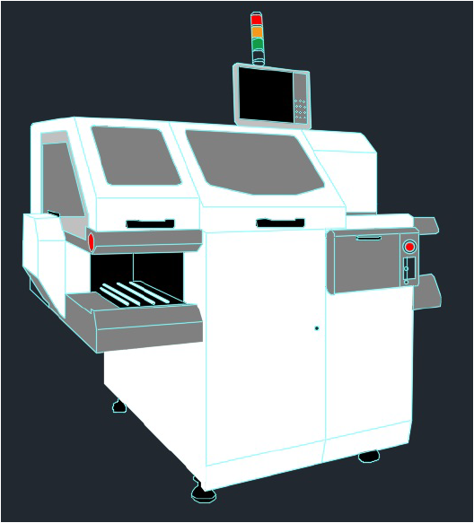

Figure 3: Example of a 3D Image of the Equipment

### Cassette Detection

|  |  |  |  |  |  |
| --- | --- | --- | --- | --- | --- |
| Requirement No. | Requirement | Area | Category | Capability | Remark |
|  | Equipment has a sensor for loading or unloading of each load port | ALL | Mandatory | Capability? |  |

### Substrate Detection Requirement

|  |  |  |  |  |  |
| --- | --- | --- | --- | --- | --- |
| Requirement No. | Requirement | Area | Category | Capability | Remark |
|  | Each load port of the equipment must have a slot map sensor | ALL | Mandatory | Capability? |  |
|  | The slot map sensor must detect cross-slotted substrates | ALL | Mandatory | Capability? |  |
|  | The slot map sensor must detect double-slotted substrates | ALL | Mandatory | Capability? |  |
|  | The equipment must be able to handle and detect different cassette types, e.g. cassette with 25 slots and/or 13 slots | ALL | Mandatory | Capability? |  |
|  | The result of the successful cassette slot mapping must be available before the substrate / cassette will be started by the equipment software (GUI, screen) or by the automation (SECS). | ALL | Mandatory | Capability? |  |

### Installation of RFID Antenna for Operator ID Reading



Figure 4: Communication of the Host, Cassette ID and Operator ID Reader

At ams OSRAM Operator ID authentication system is not integrated into the equipment software.

The below noted topics must be considered when a new equipment is bought:

|  |  |  |  |  |  |
| --- | --- | --- | --- | --- | --- |
| Requirement No. | Requirement | Area | Category | Capability | Remark |
|  | The Operator ID Antenna of ams OSRAM can be installed at the equipment e.g. front cover of the equipment | RBG | Mandatory | Capability? |  |
|  | The Operator ID Antenna of ams OSRAM shall be installed without any interference or restriction of the equipment functionality and stability | RBG | Mandatory | Capability? |  |
|  | For the fixing of an Operator ID Antenna - an area of **120 mm x 90 mm** is needed | RBG | Mandatory | Capability? |  |
|  | The Operator ID Antenna MUST NOT be fixed on moving parts (outgoing cable to reader) | RBG | Mandatory | Capability? |  |
|  | The Operator ID Antenna is equipped with LED display and therefore it MUST NOT be hidden | RBG | Mandatory | Capability? |  |
|  | The cable routing must be well-regulated without interrupting any parts of equipment with proper cable management | RBG | Mandatory | Capability? |  |
|  | The Antenna MUST NOT be influenced by chemicals | RBG | Mandatory | Capability? |  |
|  | Influence by RF is NOT allowed | RBG | Mandatory | Capability? |  |
|  | Operator ID Antennas (HF) with order number HRF.R.HFS.0I.XR.E0.10A of the company “Hermos” shall be used  *(Bought by ams OSRAM and shipped to Equipment Supplier to be Installed)* | RBG | Mandatory | Capability? |  |

Reference:

The Operator ID Antenna shall be positioned near the ams OSRAM operator PC. One must consider that the operator ID transponder is positioned in the right sleeve of the operator suit. The human ergonomic aspects must be considered.

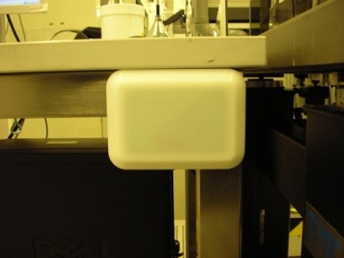

Figure 5: Operator ID Antenna

### Installation of RFID Reader for Operator ID, Cassette ID & SMIF ID Reading

The reader’s task is to collect the input of the Operator ID, Cassette ID & SMIF ID Antenna and communicate this to the ams OSRAM host system via LAN.

|  |  |  |  |  |  |
| --- | --- | --- | --- | --- | --- |
| Requirement No. | Requirement | Area | Category | Capability | Remark |
|  | For the fixing of the RFID Reader an area of 200 mm x 150 mm x 50 mm is needed | FE | Mandatory | Capability? |  |
|  | The RFID Reader must be accessible for easy replacement. Cables for the reader must be able to be connected and disconnected, and control LEDs must be visible. | FE | Mandatory | Capability? |  |
|  | The cable routing must be well-regulated | FE | Mandatory | Capability? |  |
|  | RFID Reader with the order number HRF.R.LFM.4S.XE.10.10A of the company „Hermos” shall be used.  *(Bought by ams OSRAM and shipped to Equipment Supplier to be Installed)* | FE | Mandatory | Capability? |  |
|  | The function (reading the transponder number and corresponding RED-GREEN LED verification) must be tested after installation of the different components | FE | Mandatory | Capability? |  |

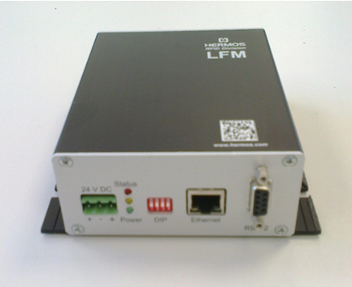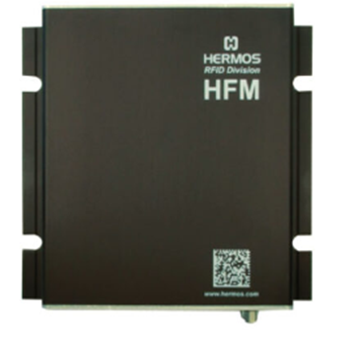

Figure 6: Hermos RFID Reader

### Integration of the Carrier & SMIF Pod RFID Antenna

At ams OSRAM the Cassette/SMIF Pod ID reading system is not integrated into the equipment software.

The hardware specification of the cassette/SMIF Pod ID reading system and operator ID authentications system is described in the **Hermos Product Manuals.**

|  |  |  |  |  |  |
| --- | --- | --- | --- | --- | --- |
| Requirement No. | Requirement | Area | Category | Capability | Remark |
|  | ams OSRAM delivers the cassette reader hardware (sensor and cable).  Supplier shall install the Cassette/SMIF ID antenna with good accessibility to the cable connection of the sensor and shall ensure the installation is without any interference or restriction of the equipment functionality and stability (e.g. cassette port is in a vacuum chamber) | FE | Mandatory | Capability? |  |
|  | The cassette/SMIF ID antenna of ams OSRAM can be installed at the equipment e.g. cassette stage, SMIF Load Port or in the loading chamber. | FE | Mandatory | Capability? |  |
|  | The distance between the 12mm transponder and the antenna must be max. 7 cm and between the 38 mm transponder and the antenna must be max. 17 cm. The critical topic is the function of the system!!! | FE | Mandatory | Capability? |  |
|  | The carrier ID antenna must not be fixed on moving parts (outgoing cable to reader). | FE | Mandatory | Capability? |  |
|  | The cable routing must be well-regulated. | FE | Mandatory | Capability? |  |
|  | The antenna must not be influenced by chemicals. | FE | Mandatory | Capability? |  |
|  | The cassette/SMIF ID antenna of ams OSRAM shall be installed without any interference or restriction of the equipment functionality and stability i.e RF interference, etc. | FE | Mandatory | Capability? |  |
|  | The used antenna depends of the possibilities of the installation and the distance to the transponder in the carrier. The following antennas of the company “Hermos” could be used (cable length) :  HRF.A.LFC.BM2.SS.20 (2m)  HRF.A.LFC.BM2.SS.30 (3m)  HRF.A.LFX.SM.SS.20 (2m)  HRF.A.LFX.SM.SS.30 (3m) | FE | Mandatory | Capability? |  |
|  | The function (reading the transponder number and corresponding RED-GREEN LED verification) must be tested after installation of the different components). | FE | Mandatory | Capability? |  |

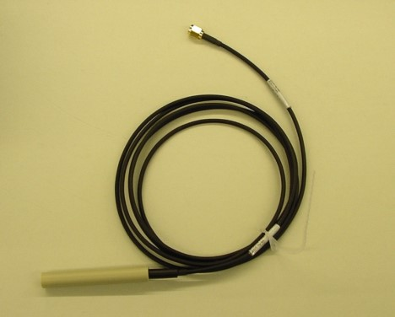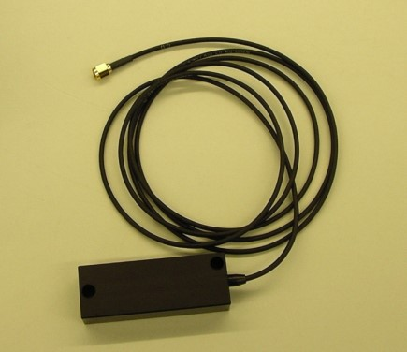

Figure 7: Hermos RFID Antennas - Rod and Block Type

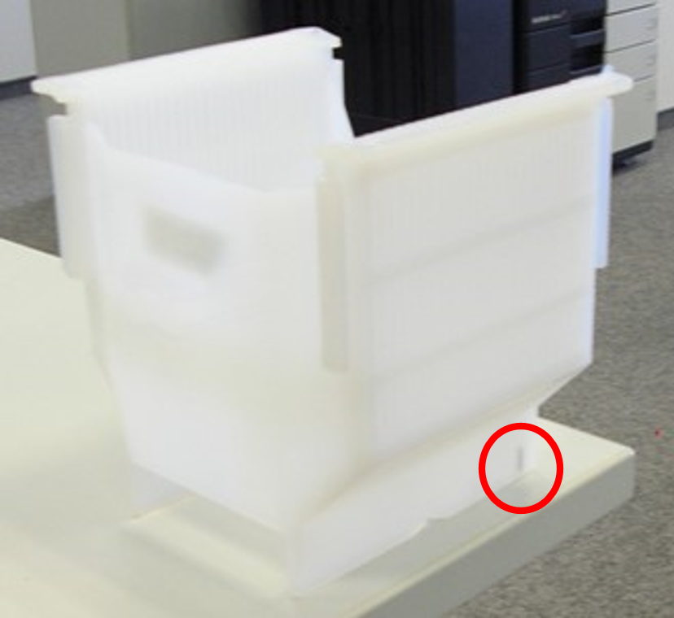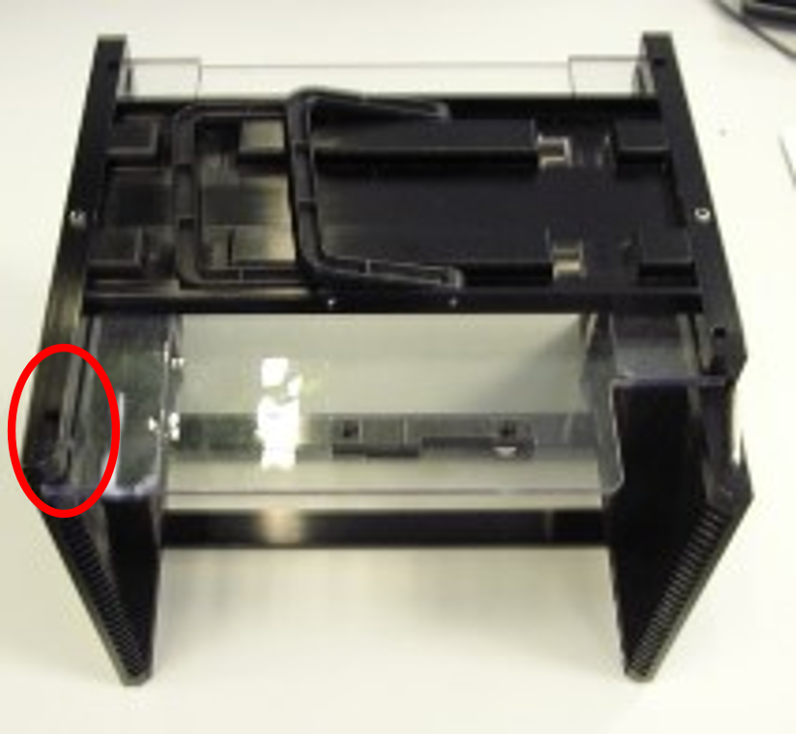

**Figure 8: RFID Transponder locations - PFA 8 inch and Film Frame 8 inch Carrier**

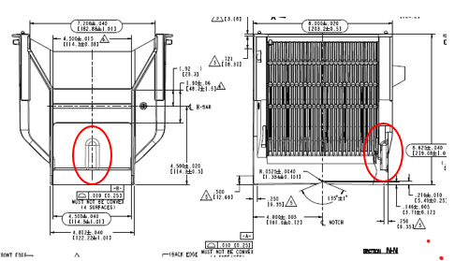 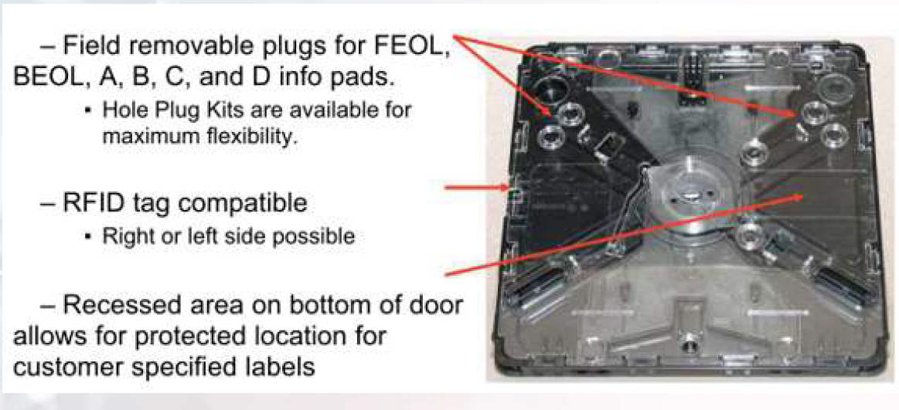

Figure 9: RFID Transponder in SMIF Carrier & SMIF Pod (OS: Transponder on the Right Side)

### Substrate ID Identification

The Substrate ID, i.e. Wafer ID or Frame ID reading is required at a particular equipment, e.g. wafer sorter, by optical hardware with compliance to SEMI E90.

The wafer inscriptions are defined in SEMI T7 (data matrix) and SEMI M12 / M13 (OCR).

|  |  |  |  |  |  |
| --- | --- | --- | --- | --- | --- |
| Requirement No. | Requirement | Area | Category | Capability | Remark |
|  | The equipment supplier must discuss and define the used Substrate ID reader hardware with ams OSRAM. | ALL | Mandatory | Capability? |  |
|  | The Substrate ID reader must read the Substrate ID on different substrate types at ams OSRAM. ams OSRAM provides for tests these substrate types. | ALL | Mandatory | Capability? |  |
|  | The Substrate ID reader usage can be switched ON/OFF in a process recipe. | ALL | Mandatory | Capability? |  |
|  | The Substrate ID reader usage can be switched ON/OFF for all process recipes. | ALL | Mandatory | Capability? |  |
|  | The Substrate ID reader can be configured in a recipe whether the Substrate ID must be verified with Substrate ID list of the host. | ALL | Mandatory | Capability? |  |
|  | The Substrate ID reader can be configured in all recipes whether the Substrate ID must be verified with Substrate ID list of the host. | ALL | Mandatory | Capability? |  |
|  | Equipment shall follow SEMI E90 to define and report for Substrate tracking. | ALL | Mandatory | Capability? |  |
|  | Equipment shall implement an equipment constant to allow the host to choose between using or not using the substrate reader. | ALL | Mandatory | Capability? |  |
|  | The host should be able to inquire any data related to specific Substrates, Substrates Locations and Batch Locations at any time by using SEMI E39 OSS service GetAttr. | ALL | Mandatory | Capability? |  |
|  | Equipment shall provide substrate tracking service for “ProceedWithSubstrate”, “CancelSubstrate” function as defined in SEMI E39. | ALL | Mandatory | Capability? |  |
|  | Equipment shall provide an event to host whenever Substrate ID reader become available or unavailable. | ALL | Mandatory | Capability? |  |

### Electronic Communication I/O Ports

|  |  |  |  |  |  |
| --- | --- | --- | --- | --- | --- |
| Requirement No. | Requirement | Area | Category | Capability | Remark |
|  | ams OSRAM accepts only the HSMS interface (SEMI E37)    Possible exceptions if necessary:  SECS-I (SEMI E4) is only accepted after the agreement by ams OSRAM and must be confirmed by OT SEMI Team.  DLL Connection via TCP/IP is only accepted in very specific cases after the agreement by ams OSRAM and must be confirmed by OT SEMI Team.  If such a DLL is used the supplier has still to offer the whole process states and material movement inclusive variables and Recipe functionality. | ALL | Mandatory | Capability? |  |
|  | Minimum 100 Mbps Ethernet with RJ45 connector(s) is be used for HSMS connection and TCP/IP connection | ALL | Mandatory | Capability? |  |

# Equipment Operational Checklist

## Substrate and Carrier Specification

|  |  |  |  |  |  |
| --- | --- | --- | --- | --- | --- |
| Requirement No. | Requirement | Area | Category | Capability | Remark |
|  | Support processing of 4" | FE | Mandatory | Capability? |  |
|  | Support processing of 6" and 8" | FE | Mandatory | Capability? |  |
|  | Has in-built substrate orientation readiness? | ALL | Mandatory | Capability? |  |
|  | Able to pre-screen all substrate at substrate magazine and store substrate slots before processing? | BE | Mandatory | Capability? |  |
|  | All single wafer processing equipment should have Substrate ID reading capability. | ALL | Mandatory | Capability? |  |

## Material Movement / Processing

### Loading / Unloading Port Identification

|  |  |  |  |  |  |
| --- | --- | --- | --- | --- | --- |
| Requirement No. | Requirement | Area | Category | Capability | Remark |
|  | Loading/Unloading ports must have unique id in equipment software. | ALL | Mandatory | Capability? |  |
|  | Loading/Unloading shall be controlled by using the id from host. If the loading/unloading port is assigned by recipe or job setting, the ID can be optional. | ALL | Mandatory | Capability? |  |
|  | In loading/unloading action or material movement, the ID shall be reported by event report. | ALL | Mandatory | Capability? |  |
|  | Has automatic LOADING / UNLOADING capability? | ALL | Mandatory | Capability? |  |
|  | Has automatic door closing capability with LOAD command  (If equipment comes with separated loading door) | ALL | Mandatory | Capability? |  |
|  | Supports Queue Job (for equipment with more than one load port) | ALL | Mandatory | Capability? |  |

### Loading, Processing and Unloading in a Module or Chamber

|  |  |  |  |  |  |
| --- | --- | --- | --- | --- | --- |
| Requirement No. | Requirement | Area | Category | Capability | Remark |
|  | The equipment must provide events (SECS) for loading / receiving, processing, and unloading / removing of the module, e.g. for wafer alignment, or chamber / processing unit. Each event should deliver logistic data (SECS, VID), e.g. lot ID / name, substrate ID / name, recipe name (PP-ID). | ALL | Mandatory | Capability? |  |
|  | The logistic data, e.g. lot or substrate name, must have the actual values of the loaded, processed, and unloaded substrate. | ALL | Mandatory | Capability? |  |



Figure 10: Events for Loading, Processing & Unloading of the Substrate with Actual Logistic Data

### Material / Substrate / Device Identification

|  |  |  |  |  |  |
| --- | --- | --- | --- | --- | --- |
| Requirement No. | Requirement | Area | Category | Capability | Remark |
|  | Able to identify component dataset with Substrate ID / Device ID? | BE | Mandatory | Capability? |  | |
|  | Supports Substrate Mapping Standard E142 where applicable i.e Metrology | ALL | Mandatory | Capability? |  | |
|  | Supports Device / Substrate validation (S14F3/F4) where applicable. | BE | Optional | Capability? |  | |

# Equipment Events Implementation

It is assumed that the equipment vendor supplies a list of all “events” identified within a particular piece of equipment. Please note that below collection events are in addition to the events required for state changes and the E30 defined events (E30 section 6).

A Collection Event Identifier (CEID) must be specified for each of these events.

## Cassette (Magazine) Detection and Cassette Slot Mapping

Apply events to cassette-based process equipment with equipment configuration in cassette detection and cassette slot mapping sensor accordingly. The expression ‘Port’ is used as defined in SEMI E30, section 4.7.2 Material Movement, in general non-SMIF 200 mm equipment does not have load ports.

|  |  |  |  |  |  |
| --- | --- | --- | --- | --- | --- |
| Requirement No. | Event name | Event description | Valid Variable ID(s) | Capability | Remark |
|  | CassetteLoaded at <port> | Cassette loaded on load port | Port ID, Cassette Type, <Port>Loaded (*=True*) | Capability? |  |
|  | CassetteRemoved at <port> | Cassette unloaded on load port | Port ID, Cassette Type, <Port>Loaded (*=False*) | Capability? |  |
|  | SlotMapReadStarted at <port> | Cassette slot scanning started at load port | Port ID | Capability? |  |
|  | SlotMapReadFinished at <port> | Cassette slot map available for load port | Port ID, Substrate/Wafer Count, cassette slot mapping result: 0: Slot empty 1: Slot occupied 2: Cross slotted | Capability? |  |
|  | SlotMapReadFailed at <port> | Cassette slot map error at load port | Port ID | Capability? |  |

## SMIF Pod Loading/Unloading

Applicable Events for Equipment configured with SMIF ports.

|  |  |  |  |  |  |
| --- | --- | --- | --- | --- | --- |
| Requirement No. | Event name | Event description | Valid Variable ID(s) | Capability | Remark |
|  | PodArrivedAtPort at <port> | A pod was loaded on SMIF Port. | Port ID, <PortState>Loaded (*=True*) | Capability? |  |
|  | PodRemovedFromPort at <port> | A pod was unloaded from SMIF port | Port ID, <PortState>Loaded (*=False*) | Capability? |  |
|  | CassetteUnloadedFromPod at <port> | At LPT, cassette was unloaded from pod. | Port ID, PortState | Capability? |  |
|  | CassetteLoadedToPod at <port> | At LPT, cassette was loaded from cassette stage to pod. | Port ID, PortState | Capability? |  |
|  | ReadyToLoad at <port> | A SMIF port has no material and is ready to be loaded with a SMIF pod. | Port ID, <Port>Loaded (*=False*) | Capability? |  |
|  | ReadyToUnLoad at <port> | A SMIF port has material ready to be unloaded from the port | Port ID, Lot ID, <Port>Loaded (*=True*)  *\*Lot ID is mandatory for batch (multiple lots) processing equipment* | Capability? |  |
|  | SMIFLocked/SMIFUnlocked at <port> | A SMIF pod was locked/unlocked | Port ID, SMIFLockState (True/False) | Capability? |  |

## Cassette (Magazine) Process Events

Applicable events to cassette-based process equipment. The expression ‘Port’ is used as defined in SEMI E30, section 4.7.2 Material Movement, in general non-SMIF 200 mm equipment does not have Load Ports.

|  |  |  |  |  |  |
| --- | --- | --- | --- | --- | --- |
| Requirement No. | Event name | Event description | Valid Variable ID(s) | Capability | Remark |
|  | CassetteStarted at <port> | Cassette started at load port | ID in process, Cassette ID etc | Capability? |  |
|  | CassetteFinished at <port> | Cassette finished at load port | Same as 8.3.1.1 | Capability? |  |
|  | CassetteAborted at <port> | Cassette aborted at load port | Same as 8.3.1.1 | Capability? |  |

## Substrate Detection, Substrate ID Reading Events

Applicable events for substrate process equipment with substrate detection sensor, ID reader.

|  |  |  |  |  |  |
| --- | --- | --- | --- | --- | --- |
| Requirement No. | Event name | Event description | Valid Variable ID(s) | Capability | Remark |
|  | SubstrateIDReadSuccessful of <reader> | Read Laser Marking / Substrate ID success. | ID in process, Laser Marking ID / substrate ID, cassette slot | Capability? |  |
|  | SubstrateIDReadError of <reader> | Read Laser Marking / Substrate ID fail. | ID in process, cassette slot | Capability? |  |
|  | SubstrateIDVerificationSuccessful | Detected Unsolicited ID | ID in process, laser marking ID / substrate ID, cassette slot | Capability? |  |
|  | SubstrateIDVerificationAborted | ID Verification aborted | ID in process, laser marking ID / substrate ID, cassette slot | Capability? |  |
|  | SubstateIDManualInput | Operator entered the Substrate ID | Entered SubstrateID | Capability? |  |

## Process Events

Applicable events for all equipment.

|  |  |  |  |  |  |
| --- | --- | --- | --- | --- | --- |
| Requirement No. | Event name | Event description | Valid Variable ID(s) | Capability | Remark |
|  | RecipeSelected | RCMD PP-Select successful | Process ID, Recipe Name, Lot ID etc. | Capability? |  |
|  | RecipeSelectFailed | RCMD PP-Select with error | Same as 8.5.1.1 | Capability? |  |
|  | ProcessingStarted | Processing started for Batch or cassette | Same as 8.5.1.1 | Capability? |  |
|  | ProcessingFinished | Processing finished for Batch or cassette | Same as 8.5.1.1 | Capability? |  |
|  | ProcessingAborted | Processing aborted for Batch or cassette | Same as 8.5.1.1 | Capability? |  |
|  | ProcessingPause | Processing paused for Batch or cassette | Same as 8.5.1.1 | Capability? |  |
|  | ProcessingError | Processing error for Batch or cassette | Same as 8.5.1.1 | Capability? |  |
|  | ProcessingContinued | Processing continues for Batch or cassette | Same as 8.5.1.1 | Capability? |  |

## Substrate Process Events in Module or Chamber

Applicable events for substrate processing.

|  |  |  |  |  |  |
| --- | --- | --- | --- | --- | --- |
| Requirement No. | Event name | Event description | Valid Variable ID(s) | Capability | Remark |
|  | ProcessingSubstrateArrived <chamber> | Processing substrate is set on processing stage / module / chamber | ID in process (lot name), CassetteID, cassette slot, SubstrateID, etc |  |  |
|  | ProcessingSubstrateRemoved <chamber> | Process substrate is removed from processing stage | Same as 8.6.1.1 |  |  |
|  | ProcessingSubstrateStarted <chamber> | Processing started for substrate | ID in process (lot name), chamber recipe name, CassetteID, cassette slot, SubstrateID, etc | Capability? |  |
|  | ProcessingSubstrateFinished <chamber> | Processing finished for substrate  Note: This event shall be only sent by the equipment, if the substrate has been completely processed (100%) according to the used recipe (PPID). | Same as 8.6.1.3 | Capability? |  |
|  | ProcessingSubstrateAborted <chamber> | Processing aborted for substrate | Same as 8.6.1.3 | Capability? |  |
|  | ProcessingSubstratePaused <chamber> | Processing paused for substrate | Same as 8.6.1.3 | Capability? |  |
|  | ProcessingSubstrateError <chamber> | Processing error for substrate | Same as 8.6.1.3 | Capability? |  |
|  | ProcessingSubstrateContinued <chamber> | Processing continues for substrate | Same as 8.6.1.3 | Capability? |  |

## Process Step Events in a Module or Chamber

Applicable events in for Process Step.

|  |  |  |  |  |  |  |
| --- | --- | --- | --- | --- | --- | --- |
| Requirement No. | Event name | | Event description | Valid Variable ID(s) | Capability | Remark |
|  | | ProcessingStepStarted in <chamber> | Processing step started in the chamber | ID in process, chamber recipe name, Substrate ID, Step ID, Step Name  In case equipment support recipe step looping: Cycle Count, Subcycle Count, Sequence Count is required (Refer to Figure 11). | Capability? |  |
|  | | ProcessingStepEnd in <chamber> | Processing step ended (finished) in the chamber | ID in process, chamber recipe name, Substrate ID, Step ID, Step Name  In case equipment support recipe step looping: Cycle Count, Subcycle Count, Sequence Count is required (Refer to Figure 11). | Capability? |  |



Figure 11: Example for Recipe Step Looping

|  |  |  |  |  |  |
| --- | --- | --- | --- | --- | --- |
| Requirement No. | Requirement | Area | Category | Capability | Remark |
|  | It is not allowed to send the step-start event until the step-end event has been sent from the previous step | FE | Mandatory | Capability? |  |

Figure 12: Examples for Recipe START/END Events

## Events for Preparation or Reconditioning in a Module or Chamber

If the equipment can carry out a preparation or reconditioning in a module or chamber between the processing of substrates or wafers, like a clean process between the plasma etch process, the equipment shall send the following SECS events:

|  |  |  |  |  |  |  |
| --- | --- | --- | --- | --- | --- | --- |
| Requirement No. | Event name | | Event description | Valid Variable ID(s) | Capability | Remark |
|  | | ReconditioningStarted in <chamber>  or CleanStarted in <chamber> | Reconditioning started, e.g. clean process, in the chamber | ID in process, chamber recipe name | Capability? |  |
|  | | ReconditioningStarted in <chamber>  or CleanEnd in <chamber> | Reconditioning ended (finished, e.g. clean process, in the chamber | ID in process, chamber recipe name | Capability? |  |

# Status Variables Implementation

Implement specified status, process/inspection data variables in the equipment and variables in the below table.

* 1. It is assumed that the vendor supplies a list of all available variables within the Equipment.
     + This includes Status Variables (SVs) and their identifiers (SVIDs),
     + Equipment constants (ECVs) and their identifiers (ECIDs),
     + Data Values (DVVALs) and their identifiers (DVNAMEs).
     + Each of the above identifiers must be unique
     + This includes CEID change, EC change or any parameter change.
     + Example: If parameter changes 5 times, equipment should also send EC or recipe parameter change 5 times too.
  2. The term VID (variable Identifier) encompasses all SVIDs, ECIDs, and DVNAMEs. Likewise, the term V (Variable Data) encompasses all SVs, ECBs, and DVVALs.
  3. This includes CEID change, EC change or any parameter change.

## Common

|  |  |  |  |  |  |
| --- | --- | --- | --- | --- | --- |
| Requirement No. | Requirement | Area | Category | Capability | Remark |
|  | Specified variable in the SEMI E30 | ALL | Mandatory | Capability? |  |
|  | **All Process Input/Output Variables including KPIVs (Key Process Input Variables) and KPOVs (Key Process Output Variables) available on equipment HMI (Human Machine Interface) must be made available via SECS/GEM (queryable as SVID or DVID. This includes targets and limits** | ALL | Mandatory | Capability? |  |

## Equipment with Load Port

|  |  |  |  |  |  |
| --- | --- | --- | --- | --- | --- |
| Requirement No. | Requirement | Area | Category | Capability | Remark |
|  | LoadPortState of <loader port> | ALL | Mandatory | Capability? |  |

## SMIF Specific Variables

|  |  |  |  |  |  |
| --- | --- | --- | --- | --- | --- |
| Requirement No. | Requirement | Area | Category | Capability | Remark |
|  | A SVID shall be provided for each SMIF port indicating the actual lock status, loaded status and transfer state (ReadyToLoad, ReadyToUnload) | ALL | Mandatory | Capability? |  |
|  | A SVID should be provided for each SMIF port indicating the communication status between SMIF port and equipment | ALL | Mandatory | Capability? |  |
|  | ALL SVIDs listed in sections 8.1 to 8.4 MUST be made available | ALL | Mandatory | Capability? |  |

# Enhanced Carrier Handoff Parallel I/O Interface (SEMI E84)

SEMI E84 defines an interface for automated carrier loading /unloading. Equipment shall be prepared to support E84 for automated handoff with **ams OSRAM AMHS components**

The supplier shall discuss with ams OSRAM the availability of E84 interface or later upgrade options.

Support for E84 is relevant for following equipment types:

* 6-inch or 8-inch wafer processing equipment for “Front of Line” production
* For equipment configured for SMIF Load Ports, SEMI 84 support is mandatory.

Note: Items defined in chapter 10.2 and 10.3 are only relevant in case SEMI E84 can be supported by the supplier.

## Standard Compliance

|  |  |  |  |  |  |
| --- | --- | --- | --- | --- | --- |
| Requirement No. | Requirement | Area | Category | Capability | Remark |
|  | Support of SEMI E84 (minimum version E84-1107) | FE | Mandatory | Capability? |  |

## Photo Coupled PI/O Interface

| Requirement No. | Requirement | Area | Category | Capability | Remark |
| --- | --- | --- | --- | --- | --- |
|  | The connector type for the passive equipment side must be type DB-25 female. | FE | Mandatory | Capability? |  |
|  | **Connector A** shall be prepared for AGV/RGV/OHT support as defined by E84.  Refer to Figure 12 – SEMI E84 Connector A Location | FE | Mandatory | Capability? |  |
|  | Signal definitions shall comply to E84 specification. | FE | Mandatory | Capability? |  |
|  | Dimensions and location of PI/O interface shall follow the definitions of E84 regarding 300mm Load Ports. | FE | Mandatory | Capability? |  |
|  | Bit assignment shall comply to E84 specification. | FE | Mandatory | Capability? |  |
|  | Signal timing during handoff (load and unload) shall comply to E84 specification. | FE | Mandatory | Capability? |  |
|  | One PI/O interface shall be provided per equipment port. | FE | Mandatory | Capability? |  |
|  | PI/O error and trace logs must be kept on equipment for minimum of seven days. | FE | Mandatory | Capability? |  |

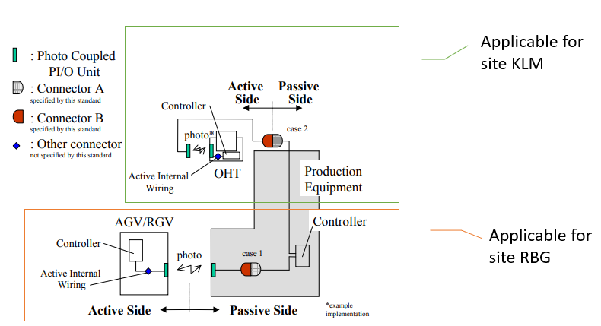

Figure 13: SEMI E84 Connector A Location

## Operation

| Requirement No. | Requirement | Area | Category | Capability | Remark |
| --- | --- | --- | --- | --- | --- |
|  | The equipment shall support two access modes. “Auto” for automated handoff and “Manual” for manual handoff.  Switching between modes must be possible at equipment UI and from Host. Event reports must be provided by equipment when access mode changes. | FE | Mandatory | Capability? |  |
|  | The actual access mode state must be provided for the host as SVID (one per equipment port). | FE | Mandatory | Capability? |  |
|  | Automatic handoff shall only be possible when equipment is in access mode state “Auto” and “Online Remote” state. | FE | Mandatory | Capability? |  |
|  | Access mode change for a port shall be rejected during handoff is active. | FE | Mandatory | Capability? |  |
|  | The equipment shall support a recovery procedure in case an error occurs during loading or unloading. The recovery mechanism should provide functions to complete or retry the handoff. | FE | Mandatory | Capability? |  |
|  | The equipment shall support continuous handoff.  Continuous handoff is in series, means one carrier transfer occurs and is then immediately followed by another.  The continuous handoff may involve “load and load”, “unload and unload” and “unload and load”. | FE | Mandatory | Capability? |  |
|  | In case the equipment requires to open/close a door to load/unload a carrier, the equipment should control the opening/closing mechanism during handoff.  No separate host action should be required for opening/closing doors for automatic handoff. | FE | Mandatory | Capability? |  |
|  | Remote commands for opening/closing doors shall also be provided for host for manual loading/unloading scenarios. | FE | Mandatory | Capability? |  |
|  | The equipment shall provide a load port transfer state model based on SEMI E87.  Actual state of each port shall be provided for the host as individual SVID per load port. | FE | Mandatory | Capability? |  |